**Name: Dileep Kumar K S**

**4th Evaluation**

**Date: 19-04-2025**

**Time: 7:30 AM to 9:00 AM**

-----------------------------------------------------------------------------------------------------------------------------------------------------------

**Question no: 5**

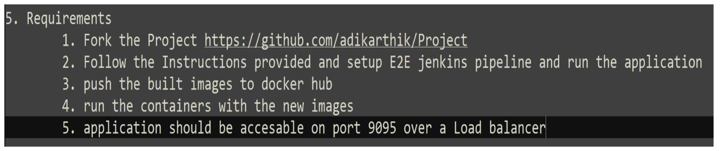

----------------------------------------------------------------------------------------------------------------------------------------------------------

**1. Fork the project**

<https://github.com/adikarthik/Project>

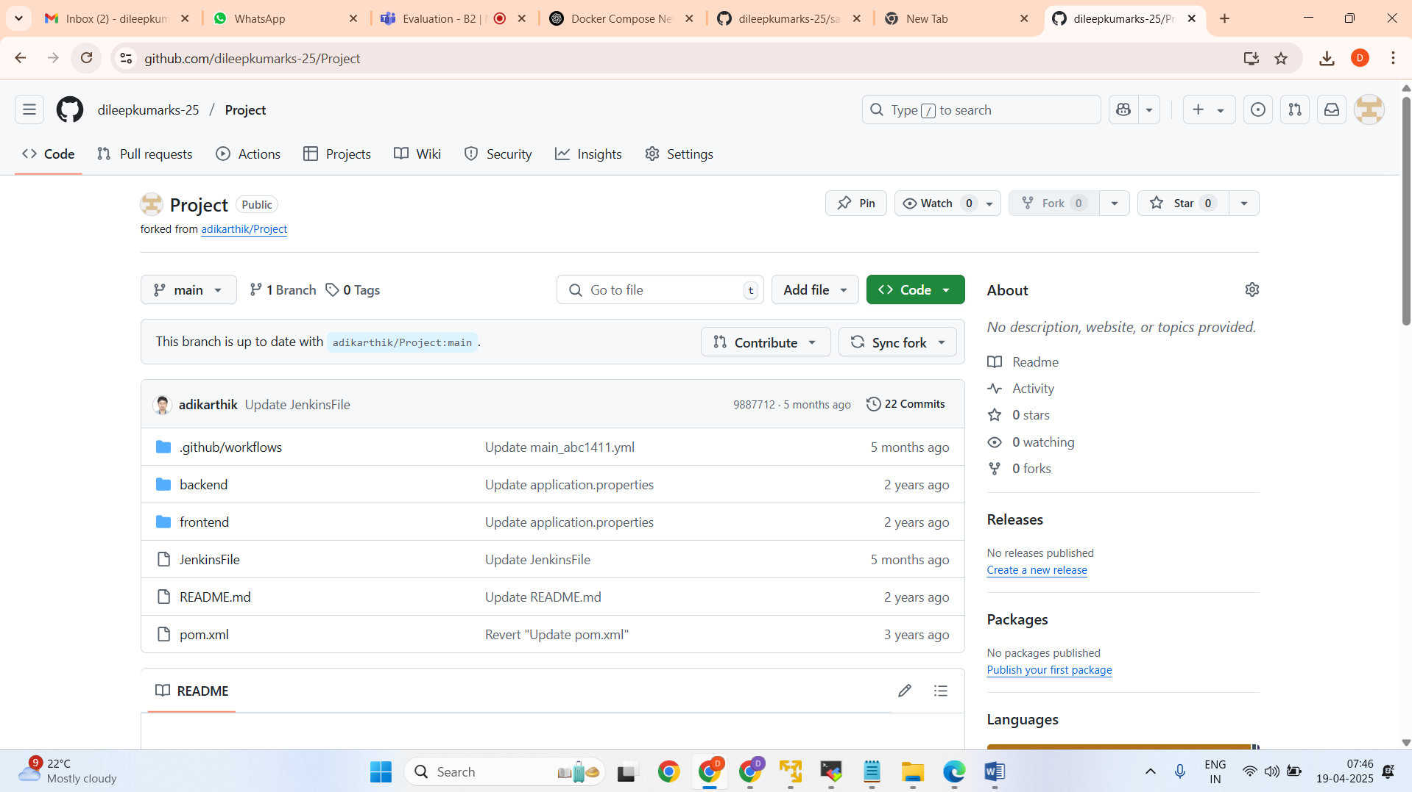

**2. Set up E2E Jenkins pipeline and run the application**

Script:

pipeline {

agent any

stages {

stage(‘cloneProject’) {

steps {

git branch:’main’, url:’https://github.com/dileepkumarks-25/Amazon-Jenkins'

}

}

stage(‘clean’) {

steps {

sh ‘mvn clean’

}

}

stage(‘compile’) {

steps {

sh ‘mvn compile’

}

}

stage(‘test’) {

steps {

sh ‘mvn test’

}

}

stage(‘build’) {

steps {

sh ‘mvn clean install’

}

}

}

}

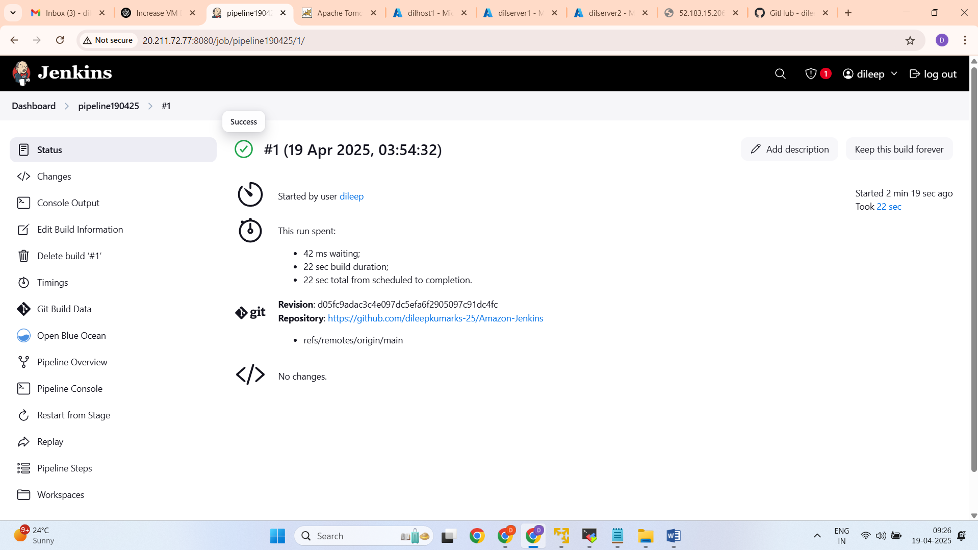

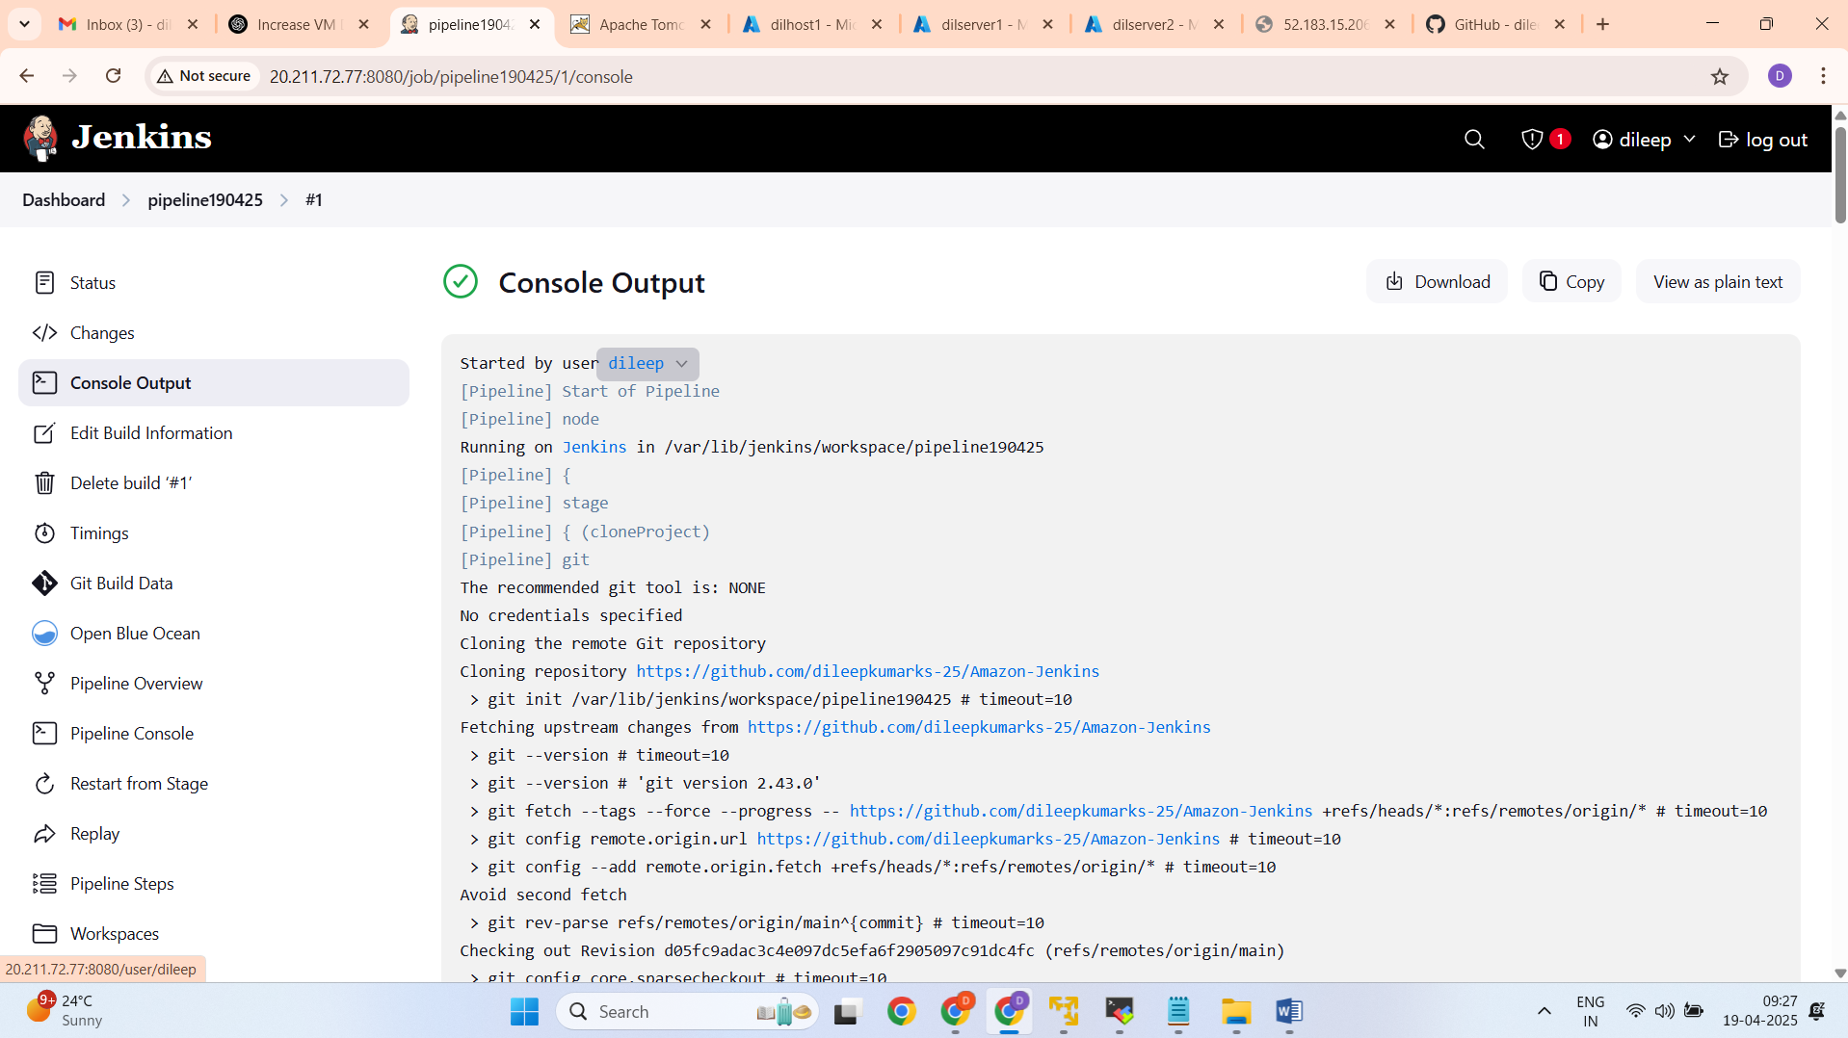

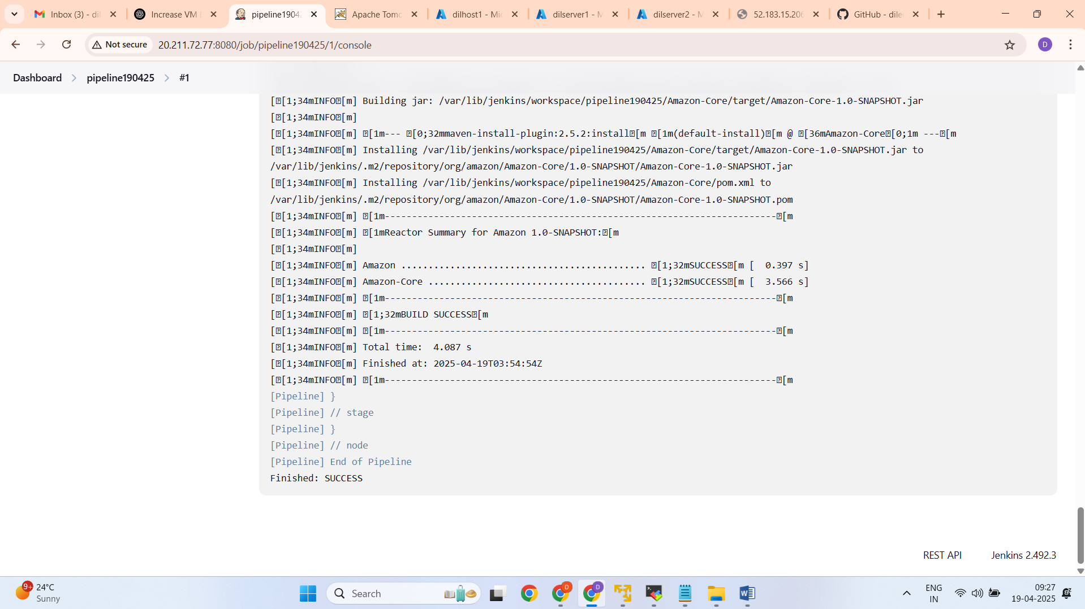

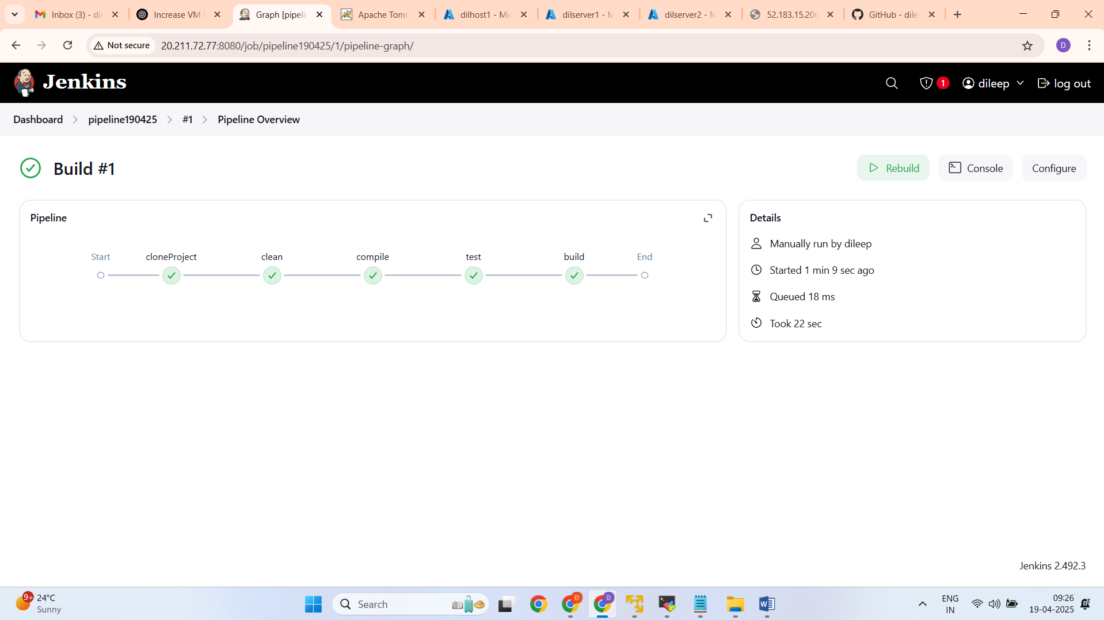

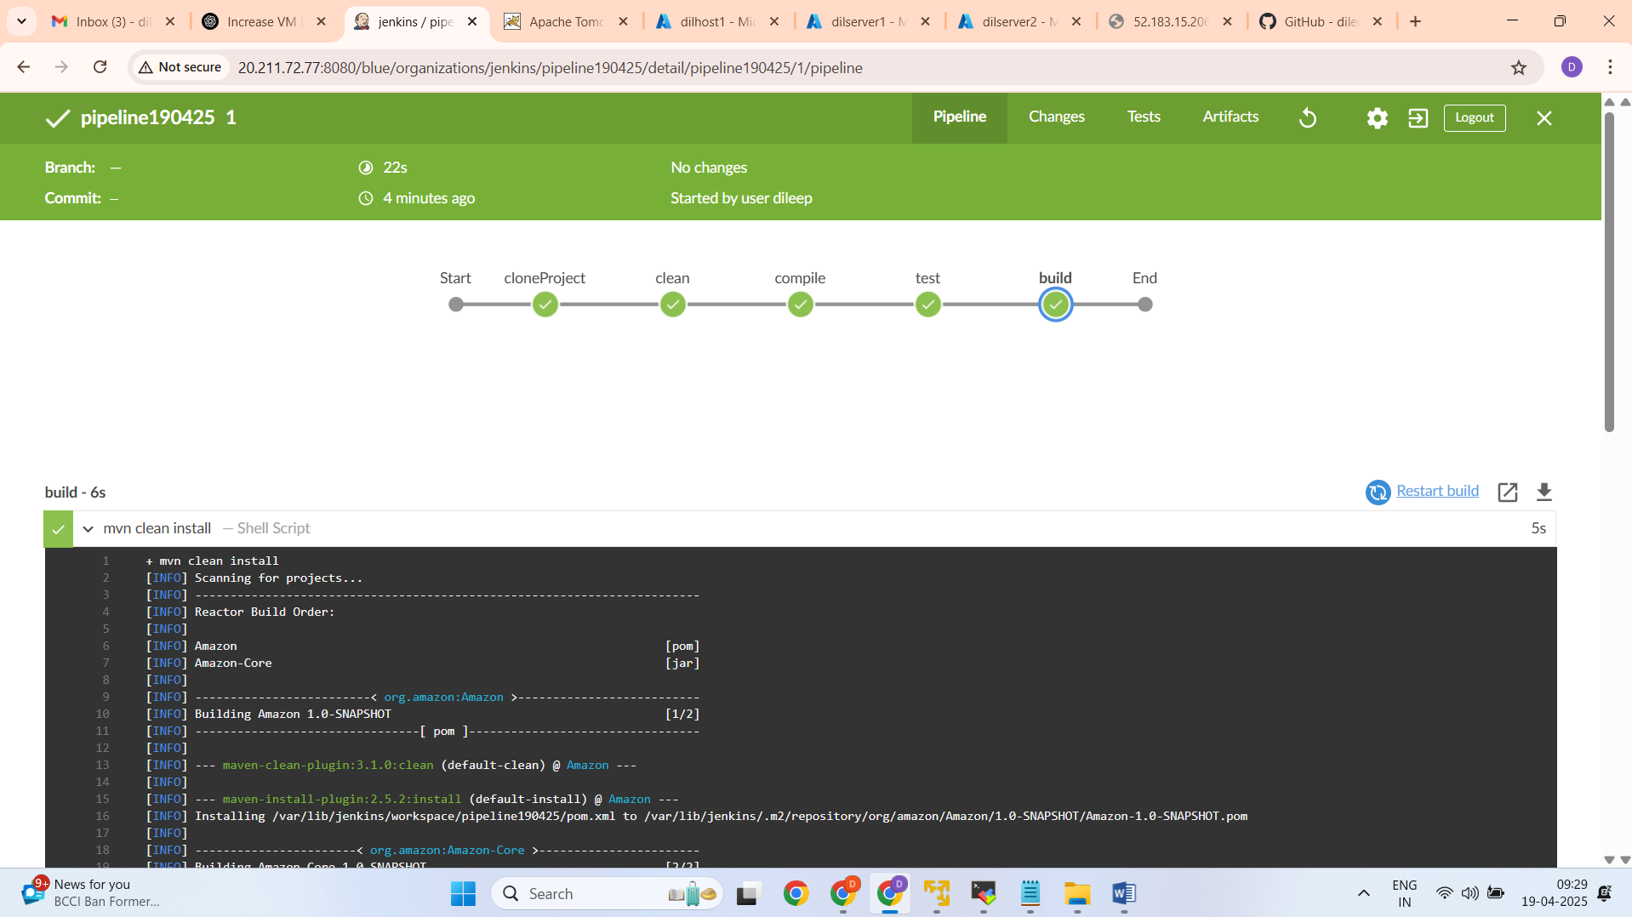

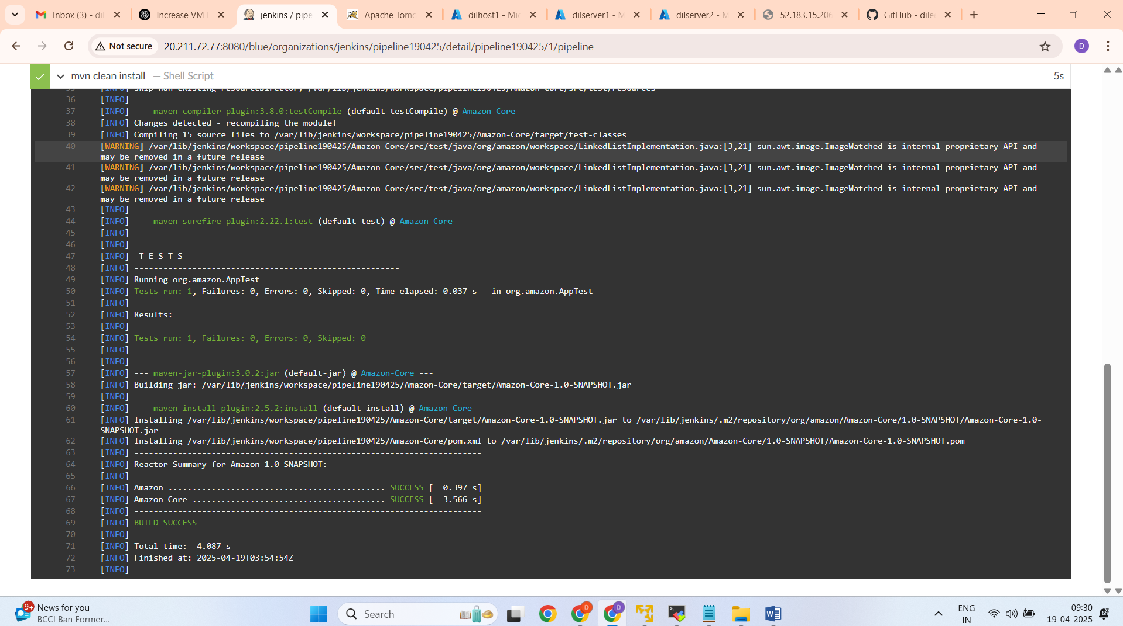

**3. Push the built images to docker hub**

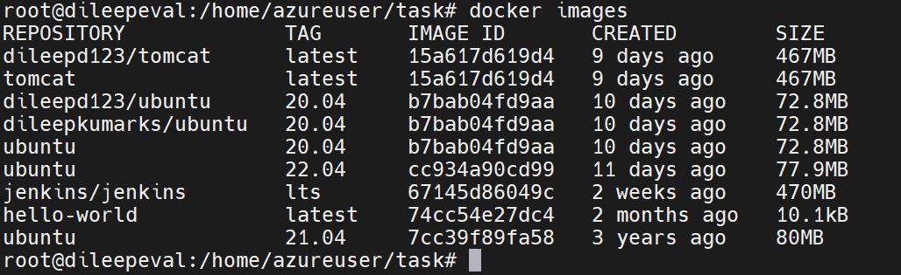

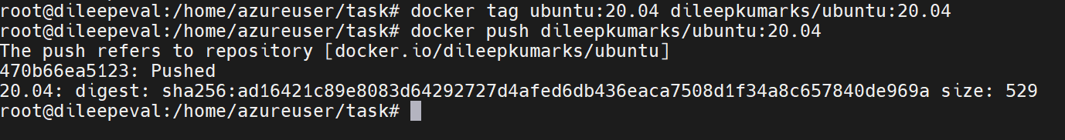

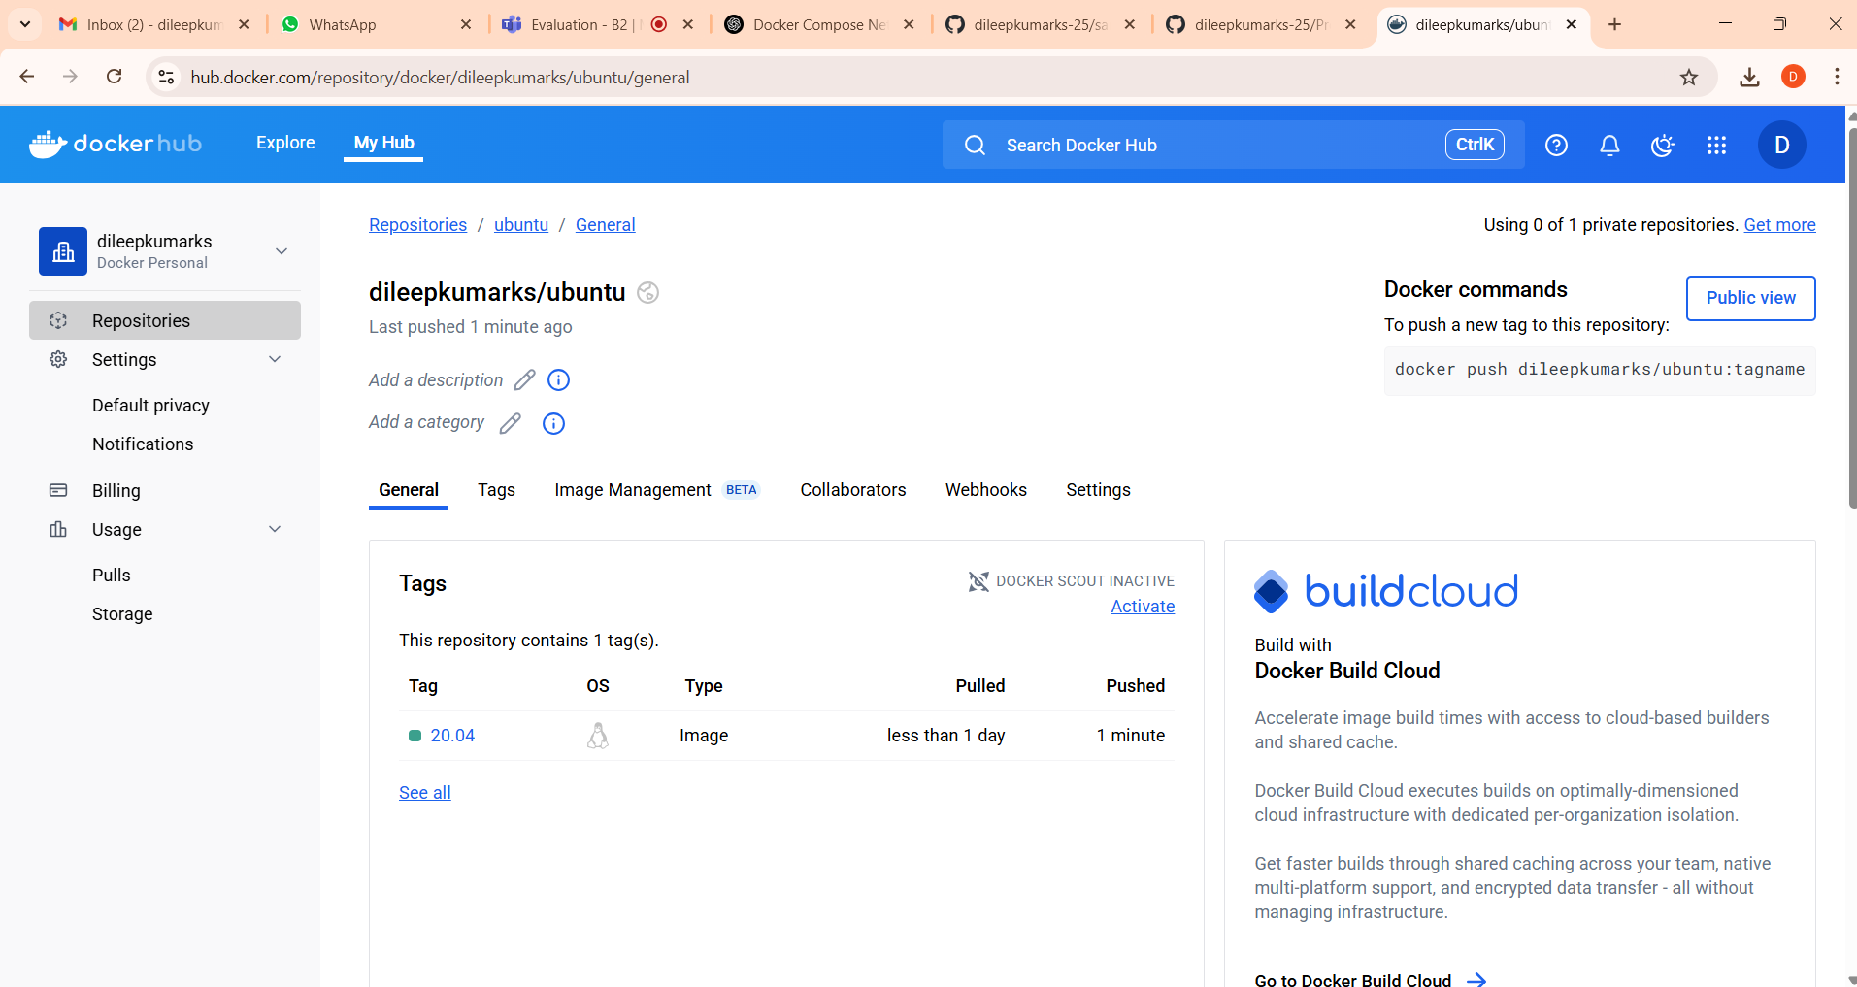

**4. Run the container with new images**

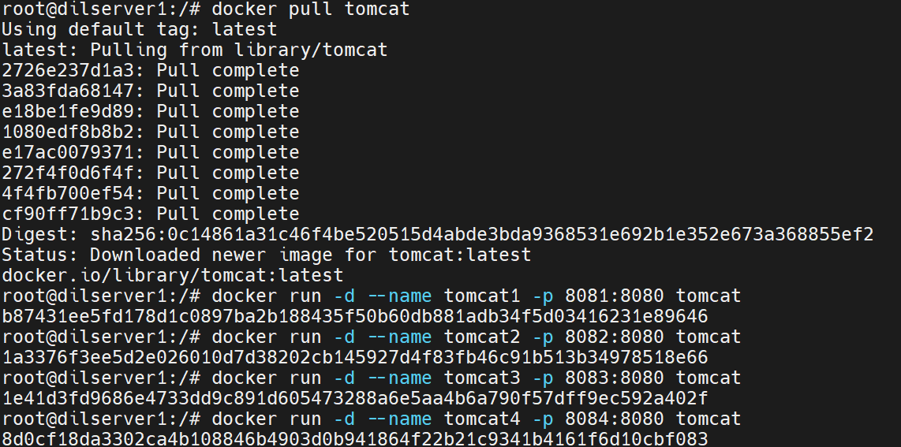



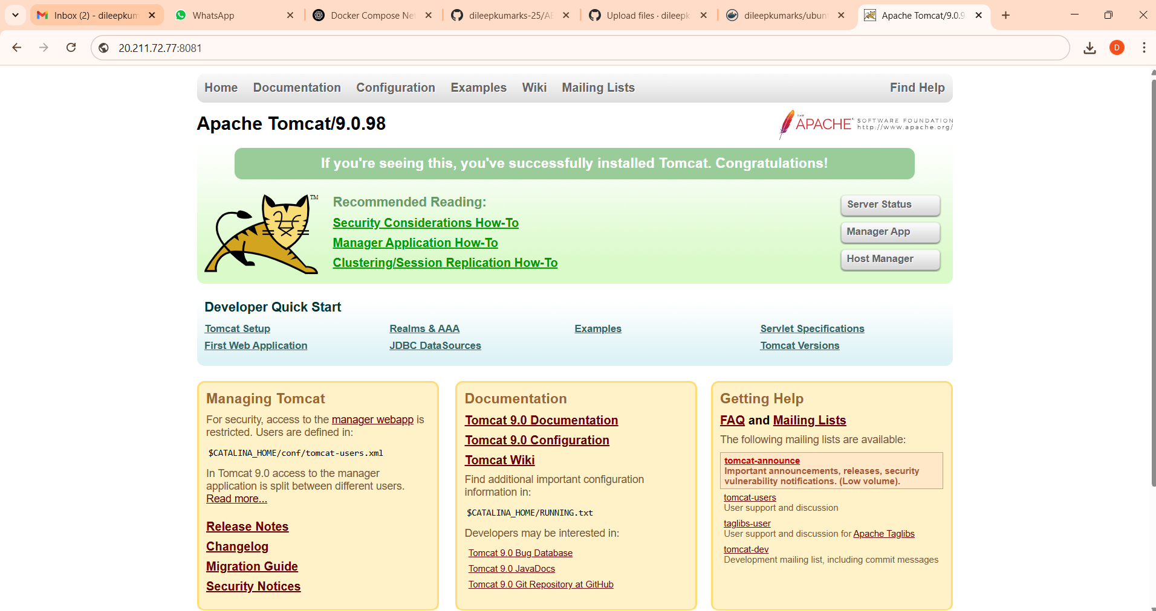

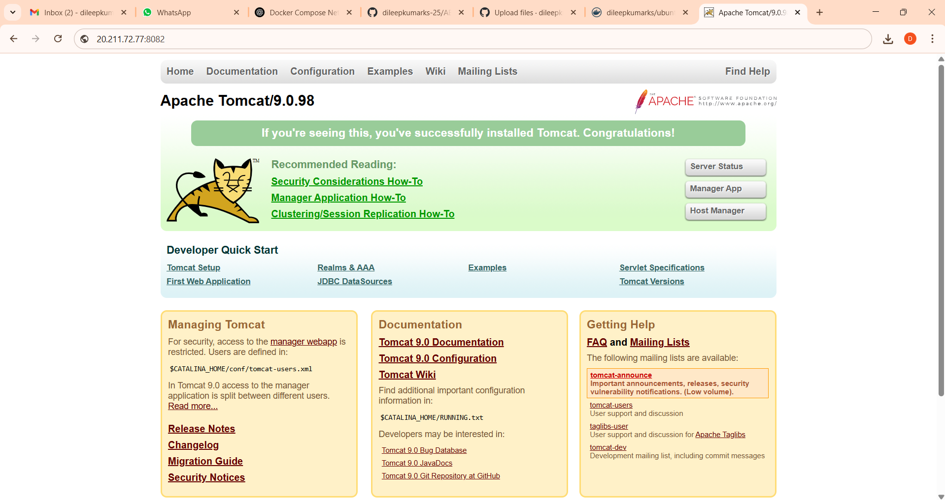

**5. Application should be accessible on port 9095 over the load balancer**

Run the Tomcat Container on Port 9095

docker run -d --name tomcat6 -p 9095:8080 tomcat



Set Up the Load Balancer (Nginx):

sudo nano /etc/nginx/sites-available/default

code: Nginx Configuration

http {

upstream tomcat_servers {

server 127.0.0.1:9095; # Port 9095, where your container is exposed

# Add more servers if you have multiple containers to load balance

}

server {

listen 9095; # Listening on port 9095

location / {

proxy_pass http://tomcat_servers; # Forward traffic to the Tomcat container

proxy_set_header Host $host;

proxy_set_header X-Real-IP $remote_addr;

proxy_set_header X-Forwarded-For $proxy_add_x_forwarded_for;

proxy_set_header X-Forwarded-Proto $scheme;

}

}

}

Restart Nginx:

sudo systemctl restart nginx

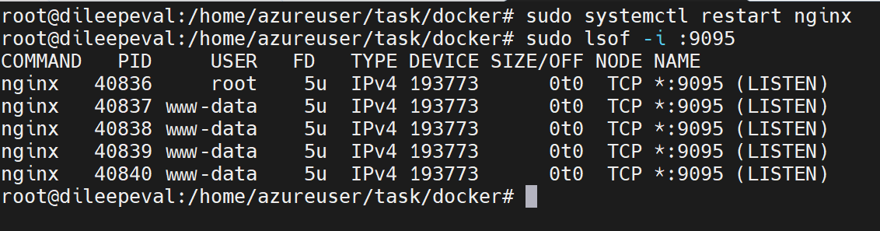

<http://20.211.72.77:9095>

nginx default page should be displayed but in my case getting Jenkins for the above url

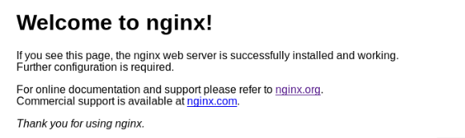

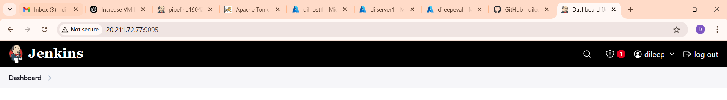

github link:

https://github.com/dileepkumarks-25/ABC1611